Day Trader Metrics
2026/06/18
Environment Setup 1
Import Data 2
Analyze Data 4
Rank Data 5
Performance Metrics 8
MACD Trends 8
Diverge/Convergence Quadrants 9
MACD in Crypto Markets 10
Corroborating Metrics 10
Final Metrics 10
Entry Points 11
Exit Points 11
Four Votes 13
2-3-Rule Thresholds 13
Honest Cynicis Check 13
Change of Heart 14
Decision Checklist 14

Environment Setup
No API keys needed in this, no trades are actioned, only an analysis of public market data.
- Data sourced live using CCXT API library, no scraping required.
- Indicators derived using pandas-ta-classic, replacing numpy.2
Run the following cell each time a new kernel starts, or whenever you start a new session. To avoid setup issues across different users, the venv environment was removed but package list requirements.txt list was maintained. This cell builds everything again and configures the notebook graphics.
Make sure to log into Binance and Alpaca accounts before running this setup below. To avoid api issues, the prferred Binance.US login is accessed here: https://docs.ccxt.com/en/latest/exchange-markets.html
import sys, subprocess
from pathlib import Path
# assign Python kernel,
REQUIRED_PY = (3, 11)
if sys.version_info[:2] != REQUIRED_PY: raise RuntimeError(
f"This notebook needs Python {REQUIRED_PY[0]}.{REQUIRED_PY[1]}, "
f"but the kernel is {sys.version.split()[0]}. Switch the kernel and re-run.")
# Install packages & versions in requirements.txt
REQUIREMENTS = Path("inputs/requirements.txt")
if not REQUIREMENTS.exists():
raise FileNotFoundError(f"{REQUIREMENTS} not found — run from the repo root.")
subprocess.run([sys.executable, "-m", "pip", "install", "--quiet",
"--break-system-packages", "--disable-pip-version-check",
"-r", str(REQUIREMENTS)], check=True,)
# import package modules and naming
import warnings, numpy as np, pandas as pd
from datetime import datetime
import ccxt
import pandas_ta_classic as ta
from pykalman import KalmanFilter
import plotly, plotly.graph_objects as go, plotly.io as pio
warnings.filterwarnings("ignore")
pio.renderers.default = "plotly_mimetype+notebook_connected"
# quick sanity check
print(f"Environment ready · python {sys.version.split()[0]} ({sys.executable})")
print(f" ccxt {ccxt.__version__} · pandas {pd.__version__} · "
f"numpy {np.__version__} · plotly {plotly.__version__}")
Environment ready · python 3.11.13 (/Users/seamus/.local/share/uv/python/cpython-3.11.13-macos-aarch64-none/bin/python)
ccxt 4.5.59 · pandas 2.3.3 · numpy 2.4.6 · plotly 6.8.0

Import Data
Live price data is sourced between 24 hours and 1 week from multiple trading platforms. Five filters were highlighted below, including EXCHANGE, SANDBOX, TIMEFRAME, LIMIT, and TOP_N. Currently, theccxt library of APIs maintains access to 105 leading crypto exchange platforms. Happy browsing!
EXCHANGE = "binance" # 105 platforms available, see https://github.com/ccxt/ccxt/wiki/Exchange-Markets)
SANDBOX = False # True = testnet / fake money (mainly for the trading step later)
TIMEFRAME = "1d" # candle size: "1m","5m","1h","4h","1d","1w"
LIMIT = 300 # candles pulled per coin (max 1000)
TOP_N = 20 # how many of the most-traded /USDT pairs to scan
exchange = getattr(ccxt, EXCHANGE)()
exchange.set_sandbox_mode(SANDBOX)
print(f"Configured: {EXCHANGE} | sandbox={SANDBOX} | {TIMEFRAME} candles x{LIMIT} | top {TOP_N}")
Configured: binance | sandbox=False | 1d candles x300 | top 20
def calculate_indicator(symbol, timeframe=TIMEFRAME, limit=LIMIT):
bars = exchange.fetch_ohlcv(symbol, timeframe=timeframe, limit=limit)
df = pd.DataFrame(bars[:-1], columns=["timestamp","open","high","low","close","volume"])
df["timestamp"] = pd.to_datetime(df["timestamp"], unit="ms")
df = df.set_index("timestamp")
close, low = df["close"].iloc[-1], df["low"].iloc[-1]
# Kalman threshol & smoother
kf = KalmanFilter(transition_matrices=[1], observation_matrices=[1],
initial_state_mean=0, initial_state_covariance=1,
observation_covariance=1, transition_covariance=.01)
state_means, _ = kf.filter(df["close"].values)
df["kf_mean"] = state_means
kalman = df["kf_mean"].iloc[-1]
above_kalman = bool(low > kalman)
# Trend: Is EMA-14 leading the Kalman mean?
df.ta.ema(length=14, append=True)
ema_cross = bool(df["EMA_14"].iloc[-1] > kalman)
# Bollinger(14) mean-reversion envelope.
bb = df.ta.bbands(length=14)
bbl, bbu = bb["BBL_14_2.0"].iloc[-1], bb["BBU_14_2.0"].iloc[-1]
# Ichimoku projectionse.
ich = df.ta.ichimoku()[1]
isa_9, isb_26 = ich["ISA_9"].iloc[-1], ich["ISB_26"].iloc[-1]
# Archer MA trend flag, RSI, Choppiness.
amat = bool(df.ta.amat()["AMATe_LR_8_21_2"].iloc[-1] == 1)
rsi = float(df.ta.rsi().iloc[-1])
chop = round(float(df.ta.chop().iloc[-1]), 2)
# Candle shape check: any doji / dragonfly / gravestone candles?
o, h, l, c = df["open"].iloc[-1], df["high"].iloc[-1], df["low"].iloc[-1], df["close"].iloc[-1]
rng = h - l
body = abs(c - o)
upper = h - max(o, c)
lower = min(o, c) - l
doji = bool(rng > 0 and body <= 0.10 * rng)
dragonfly = bool(doji and lower >= 0.6 * rng and upper <= 0.10 * rng)
gravestone = bool(doji and upper >= 0.6 * rng and lower <= 0.10 * rng)
# MACD (12,26,9)
macd_line = df["close"].ewm(span=12, adjust=False).mean() - df["close"].ewm(span=26, adjust=False).mean()
signal_line = macd_line.ewm(span=9, adjust=False).mean()
macd, sig = macd_line.iloc[-1], signal_line.iloc[-1]
macd_prev, sig_prev = macd_line.iloc[-2], signal_line.iloc[-2]
macd_buy = bool(macd_prev <= sig_prev and macd > sig)
macd_sell = bool(macd_prev >= sig_prev and macd < sig)
macd_below_zero = bool(macd < 0)
buy = amat and ema_cross and above_kalman
sell = (not amat) and (not ema_cross) and (not above_kalman)
row = dict(Symbol=symbol, Buy=buy, Sell=sell, Close=round(float(close), 4),
RSI=round(rsi, 2), Chop=chop, AMAT=amat,
Ichimoku_9=round(float(isa_9), 4), Ichimoku_26=round(float(isb_26), 4),
EMA_gt_Kalman=ema_cross, Low_gt_Kalman=above_kalman,
Doji=doji, Dragonfly=dragonfly, Gravestone=gravestone,
MACD=round(float(macd),4), MACD_Signal=round(float(sig),4),
MACD_Buy=macd_buy, MACD_Sell=macd_sell, MACD_below_zero=macd_below_zero)
return df, row
def plot(symbol):
df, _ = calculate_indicator(symbol)
fig = go.Figure(go.Candlestick(x=df.index, open=df.open,
high=df.high, low=df.low, close=df.close, name=symbol))
fig.add_trace(go.Scatter(x=df.index, y=df["kf_mean"],
name="Kalman", line=dict(color="orange", width=2), opacity=0.7))
fig.add_trace(go.Scatter(x=df.index, y=df["EMA_14"],
name="EMA-14", line=dict(color="purple", width=2), opacity=0.7))
fig.update_layout(title=symbol, xaxis_rangeslider_visible=False)
return fig
def color_boolean(val):
if val is True: return "background-color: lightgreen"
if val is False: return "background-color: pink"
return "background-color: lightblue"
print("Engine ready.")
Engine ready.

Analyze Data
The following pulls 300 daily candles and computes the following:
- Kalman Filter: a price smoothing noisy fluctuations, key indicator of close of day price strength
- Bollinger Bands: An elastic envelope derived from 14-day price average. Narrowing suggests quiet market, flaring suggest volatile.
- Ichimoku Spans: Two mean price projections used as trend map, suggesting uptrend or downtrends between 9 adn 26 days.
- AMAT: Archer Moving Average Trends used as binary indicators showing diverging fast and slow averages, or aligning showing sustained trend (1 = “trending up”).
- Relative Strength Index (RSI). Speedometer, above 70, price running fast risks overselling and then cooling off. Below 30 may mean due to bounce.
- Choppiness Index: High values suggest inertia, low suggest clean trend.
Key values in these metrics in sell and buy point variables above, copied here again for review: ema_crossover = ema_14 > ema_91
The originals scanned every Binance.US ticker, which is slow and noisy. Here we take the most liquid spot /USDT pairs by quote volume. Raise TOP_N to widen the scan; each extra symbol adds roughly a second.
tickers = exchange.fetch_tickers()
pairs = [(s, d.get('quoteVolume') or 0) for s, d in tickers.items()
if s.endswith('/USDT') and ':' not in s]
universe = [s for s, _ in sorted(pairs, key=lambda x: -x[1])[:TOP_N]]
today = datetime.now().strftime('%Y-%m-%d')
print(f"{today}: scanning {len(universe)} pairs")
universe
2026-06-18: scanning 20 pairs
['USDC/USDT',
'BTC/USDT',
'ETH/USDT',
'WLD/USDT',
'USD1/USDT',
'SOL/USDT',
'XRP/USDT',
'ZEC/USDT',
'BNB/USDT',
'XLM/USDT',
'NIGHT/USDT',
'RE/USDT',
'NEAR/USDT',
'SPCXB/USDT',
'FDUSD/USDT',
'RLUSD/USDT',
'UNI/USDT',
'ASTER/USDT',
'U/USDT',
'XPL/USDT']

Rank Data
Run the engine over the universe into one table. The try/except skips symbols too new to have full indicator history. For example a token listed days ago has no Ichimoku cloud and skips these values instead of hiding them.
rows = []
for symbol in universe:
try: rows.append(calculate_indicator(symbol)[1])
except Exception as e: print(f"skip {symbol}: {type(e).__name__}")
results = pd.DataFrame(rows)
print(f"\nscored {len(results)} pairs | {int(results.Buy.sum())} buys | {int(results.Sell.sum())} sells")
results.head()
skip RE/USDT: KeyError
skip SPCXB/USDT: KeyError
scored 18 pairs | 4 buys | 6 sells

Symbol | Buy |  |  | Sell |  |  | Close |  |  | RSI |  |  | Ichimok9 |  |  | Ichimok9 |  |  | Ichimok26 |  |  | EMA GT Kalman |  |  | Low GT Kalman
USDC/USDT | False |  |  | False |  |  | 1.0009 |  |  | 57.78 |  |  | 1.0080 |  |  | 1.0080 |  |  | 1.0109 |  |  | True |  |  | False
BTC/USDT | False |  |  | True |  |  | 62958.0 |  |  | 34.91 |  |  | 66314.5 |  |  | 66314.5 |  |  | 70990.4 |  |  | False |  |  | False
ETH/USDT | False |  |  | True |  |  | 1711.1 |  |  | 38.62 |  |  | 1775.16 |  |  | 1775.10 |  |  | 1964.7 |  |  | False |  |  | False
WLD/USDT | True |  |  | False |  |  | 0.6431 |  |  | 66.55 |  |  | 0.5374 |  |  | 0.5374 |  |  | 0.4748 |  |  | True |  |  | True
USD1/USDT | True |  |  | False |  |  | 1.0009 |  |  | 63.39 |  |  | 1.0001 |  |  | 1.0001 |  |  | 1.0000 |  |  | True |  |  | True
Symbol |  | Doji |  |  | Dragonfly |  |  | Gravestone |  |  | MACD |  |  | MACD Signal |  |  | MACD Buy |  |  | MACD Sell |  |  | MACD below zero
USDC/USDT |  | False |  |  | False |  |  | False |  |  | 0.0000 |  |  | -0.0000 |  |  | True |  |  | False |  |  | False
BTC/USDT |  | False |  |  | False |  |  | False |  |  | -2437.6307 |  |  | -2930.6 |  |  | False |  |  | False |  |  | True
ETH/USDT |  | False |  |  | False |  |  | False |  |  | -83.5294 |  |  | -106.67 |  |  | False |  |  | False |  |  | True
WLD/USDT |  | False |  |  | False |  |  | False |  |  | 0.0772 |  |  | 0.0632 |  |  | False |  |  | False |  |  | False
USD1/USDT |  | True |  |  | False |  |  | False |  |  | 0.0002 |  |  | 0.0001 |  |  | False |  |  | False |  |  | False

top = (results.sort_values(['Buy','EMA_gt_Kalman','AMAT','RSI'], ascending=[False,False,False,True]).reset_index(drop=True).head(10))
bottom = (results.sort_values(['Sell','AMAT','RSI'],ascending=[False,False,False]).reset_index(drop=True).head(10))
print("ranked.")
if top['Buy'].any():
print("Entry candidates showing bullish trends and Kalman lead prices:")
for s in top.loc[top['Buy'], 'Symbol']: print(" ", s)
else: print("No long signals showing strongest-ranked names.")
top.style.map(color_boolean)
ranked.
Entry candidates showing bullish trends and Kalman lead prices:
XPL/USDT
USD1/USDT
XLM/USDT
WLD/USDT
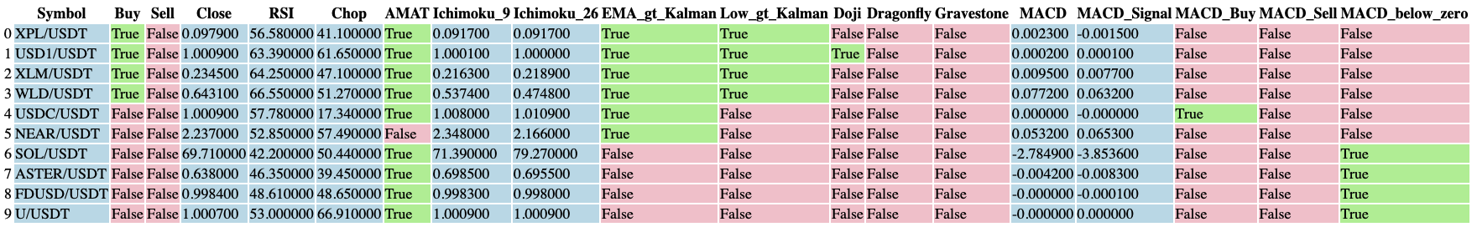
A chart showing strongest buy candidate, with the Kalman and EMA-14 trend lines:
from IPython.display import HTML
HTML(plot(top['Symbol'].iloc[0]).to_html(include_plotlyjs="cdn", full_html=False))
<IPython.core.display.HTML object>
# Save the chart as a standalone, self-contained HTML file you can open in any browser.
fig = plot(top['Symbol'].iloc[0])
fig.write_html('outputs/chart.html', include_plotlyjs=True, auto_open=False)
print('saved outputs/chart.html')
saved outputs/chart.html

Performance Metrics

MACD Trends
stands for Moving Average Convergence Divergence. Gerald Appel, 1970s. It is a momentum and trend tool, plotted in its own panel below price rather than on the candles. Because the MACD line is fast EMA minus slow EMA, it crosses its own zero line at the same moment the 12-EMA crosses the 26-EMA on the price chart. These crossovers are key indicators in day trading, often sound buy points where MACD crosses above or sell points where crosses below. Additionally, the zero-line cross occur during bullish context, with below zero suggesting change to bearish trend. However, the signal-line tends to occur earlier than the zero line cross that offers greater notice of opportunity. Trade off is falling into more false starts.
Beneath the line graph, the histogram can add to our predictions providing distances between lines that guide us to whenm lines cross. The height of these distances represents momentum, so that a growing histogram indicates accelerating divergence. Alternatively, a shrinking histogram of converging lines suggests momentum is fading signalling a likely turn.
Divergence presents important metric in day trading that is least mechanical to read. Observing changing swings between MACD highs and lows, we can identify a shift in trends is expected. Bearish divergence can be characterised by higher highs while MACD show lower highs that caution an uptrend is hollow. aternatively, a bullish divergence can appear with lower lows while MACD presents higher lows that caution a downtrend is exhausting. Need guidance on this, but seems
divergence is mostly used to protect a position before change, rather than a precise entry to trade.

Diverge/Convergence Quadrants
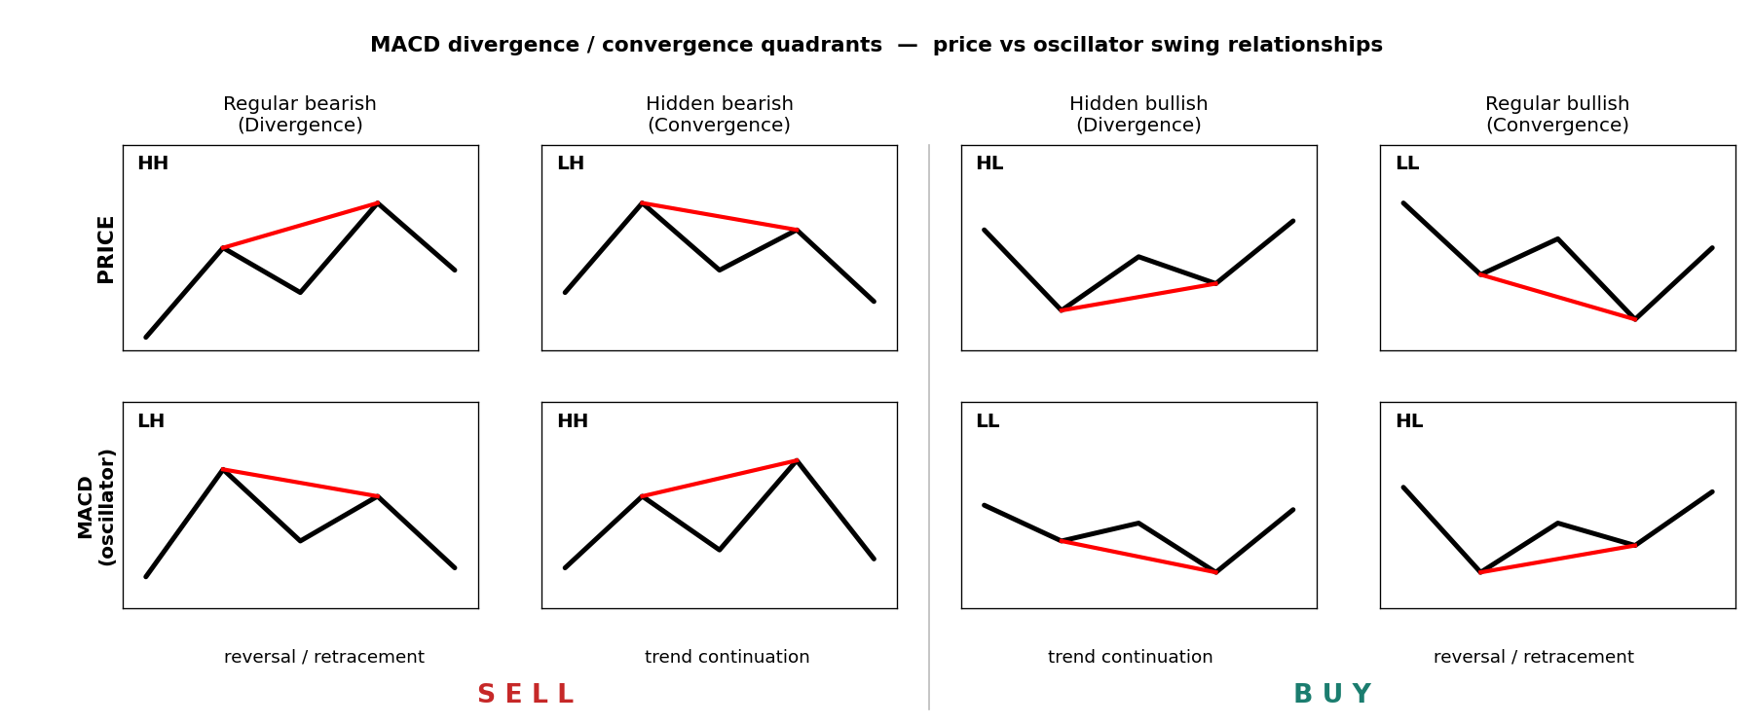
The full taxonomy compares the last two price swings against the matching MACD swings. Notation: HH higher high, HL higher low, LH lower high, LL lower low.
Price | MACD | Source term | Standard term | Reading | Action
Higher high | Lower high | Divergence | Regular bearish | reversal / retracement | SELL
Lower high | Higher high | Convergence | Hidden bearish | trend continuation (down) | SELL
Higher low | Lower low | Divergence | Hidden bullish | trend continuation (up) | BUY
Lower low | Higher low | Convergence | Regular bullish | reversal / retracement | BUY
Two cautions from the research. First, terminology is not standardised: GoodCrypto defines “divergence” as price stronger than the indicator and “convergence” as price weaker, which is the geometry above but the opposite word to how many texts use them. Read the HH/HL/LH/LL pattern, not the label. Second, a single chart can show mixed signals: in their BTC example the peaks diverged while the troughs converged, netting out bearish only because the peak structure dominated. Weigh both swing series, do not act on one line in isolation.

MACD in Crypto Markets
MACD is well respected in BTC and ETH markets, but cannot be handled in isolation. It is recommended
to consider alonside position sizing and a expected stop. Some suggest a good crypto technique should draw the trendline on the MACD itself, not only on price. For example, in the May 2021 BTC top, price held a rising trendline while the MACD was already tracing a falling one. The MACD trendline broke first. The same setup appeared on the SOL 4h chart, pushing higher highs into resistance while MACD showed clearly lower highs. Was this a textbook bearish divergence, as it preceded the stall?
The choice of timeframe is important, but does not change whether MACD works; a 4h or 1h MACD simply updates faster than a daily one. The real limiter is volatility: the more violent the asset, the less any indicator forecasts cleanly, so widen confirmation in fast markets.

Corroborating Metrics
MACD gives momentum but poor at signaling overbought/oversold thresholds, so traders may confirm crossover against a second indicator and only act when both agree. In rough order of their selective applications:
Partner | What it adds | Entry rule | Exit
Relative Vigor Index | closing strength vs range | both cross same direction | MACD opposite cross
Money Flow Index | price + volume, few signals | MFI overbought/oversold then MACD cross | MACD opposite cross
TEMA (50) | triple-smoothed trend | price breaks TEMA and MACD crosses | contrary signal from both
TRIX | momentum oscillator | MACD cross matched by TRIX zero-cross | MACD cross, or looser, TRIX zero-cross
Awesome Oscillator | 5/34 SMA momentum | MACD cross confirmed by AO | both turn contrary
MA (20) | trend validation | price tests the 20-MA, then MACD crosses up | —
The shared idea is the guardrail we already build into the metric: do not take a bare crossover, require corroboration. A second indicator is one form of that; our epsilon noise band and confirmation bars are another, internal to MACD itself. MFI’s volume gate is the most distinct addition and the strongest candidate to add next, since the histogram and slope already cover much of what RVI, TRIX, and AO contribute.

Final Metrics
The current iteration targets these metrics by defining the following variables, including cross_up and cross_down crossover points; as well as guarded_buy and guarded_sell constraints. These were applied as conservative measures around noise which we found recommended in majority of readings. Histogram variables were derived for both hist_slope and converging flags to highlight early fade nearing zero. Divergence points were constructed at swing pivot points for variables of bear_div and bull_div representing bearish and bullish quadrant data of regular bounds. MACD breaks and hidden divvergence, which are not yet coded, are next target. strength is compiled from band clearances, slope spikes, zero field, and corroboration by divergence, which was numerically viewed as significantly weighted swing series.
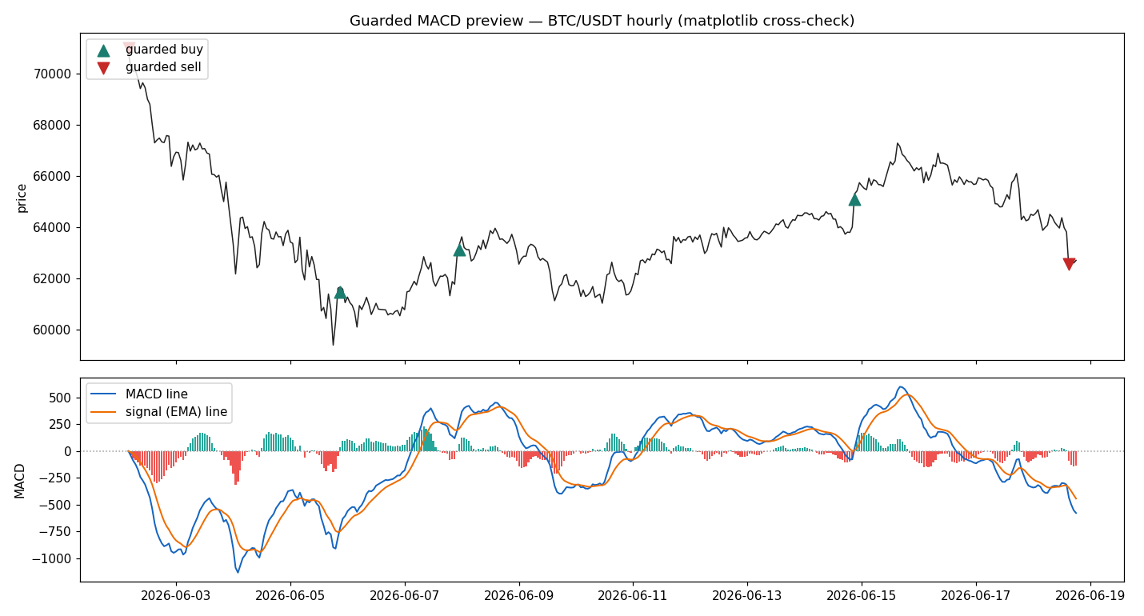
BTC preview

Entry Points
Buy trends are displayed first with Kalman flags displayed and lowest RSI scores at the top. Sell points are presented as the mirror to these, which is also characteristic of how the computational checklist was built between them.

Exit Points
if bottom['Sell'].any():
print("Exit candidates trending down showing prices below Kalman:")
for s in bottom.loc[bottom['Sell'], 'Symbol']: print(" ", s)
else: print("No short signals today; showing weakest-ranked names.")
bottom.style.map(color_boolean)
Exit candidates trending down showing prices below Kalman:
ZEC/USDT
NIGHT/USDT
XRP/USDT
ETH/USDT
BNB/USDT
BTC/USDT

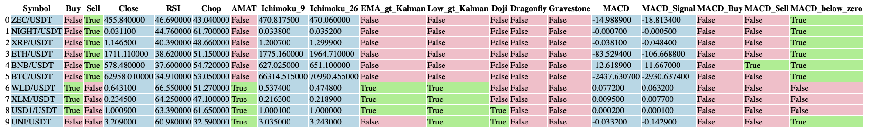

Four Votes
MACD is derived as guarded crossover points in the macd_lab metrics which is presented in terms of a regime going forward. That is, after a guarded buy the stance stays +1 until a guarded sell flips it. MA crossover is the plain fast-over-slow test from the MA-crossover notebook, +1 when the 20-period SMA is above the 50, -1 below.
Fibonacci is contextual: on a rising leg, where price pulled back into the 0.5-0.618 golden pocket votes +1 to buy the dip; on a falling leg, price bounced into that pocket votes -1 (sell the rip); otherwise 0. Candles are an adjusted but assuming pattern, where +1 engulfs on a bullish and -1 on bearish, held live for a few bars before lapsing.
Worth noting that we detected a real bug in Candle module, a positional column rename that swapped open and close, so its pattern was informed by invalid fields. The version here uses the standard engulfing definition derived from valid columns.

2-3-Rule Thresholds
We aimed for two-point agreement as the standard rule, and used the stricter three-point version when a setup had fewer trades to learn from. Localised bandwidths were tuned tightly to conditions, and the backtest only ever used information that would have been available at the time, nothing from hindsight. A signal fires the moment the score crosses the threshold, so the dashboard shows more markers than the backtest actually trades. That gap is expected: if a second buy signal fires while we already hold a position, it doesn’t open a new one.
score = w_macd*MACD + w_ma*MA + w_fib*Fib + w_candle*Candle (weights default 1)
BUY fires when score first reaches +threshold (default +2)
SELL fires when score first reaches -threshold (default -2)

Honest Cynicis Check
Hourly data, the ten-coin universe, about 1000 bars (~41 days), 0.1% fee per side, long-flat, threshold 2. This window was a broad crypto downtrend.
coin | strategy | buy & hold | trades | win % | max DD
BTC | -1.4% | -21.3% | 4 | 50 | -7.3%
ETH | -9.2% | -26.1% | 5 | 20 | -16.1%
SOL | -19.8% | -22.1% | 6 | 33 | -36.9%
BNB | -0.9% | -9.9% | 5 | 40 | -6.7%
XRP | -6.3% | -17.9% | 4 | 50 | -15.5%
ADA | -16.9% | -38.2% | 5 | 20 | -22.0%
AVAX | -8.0% | -33.6% | 6 | 33 | -16.7%
LINK | -19.7% | -20.3% | 7 | 29 | -25.4%
LTC | -10.1% | -23.4% | 4 | 25 | -17.1%
DOGE | -9.2% | -22.6% | 3 | 33 | -15.1%
mean | -10.1% | -23.5%
Read it plainly. The engine lost money on every coin, but lost roughly half of what holding lost, because staying flat through the downtrend avoided the worst of it. That is a drawdown-reduction property, not an edge. Beating buy-and-hold by being absent during a fall is easy and does not survive into a rising or sideways market, where sitting flat means missing gains. Win rates of 20 to 50 percent confirm there is no demonstrated predictive skill here yet. This matches the project’s standing NO-GO finding: cleaner instrumentation, still no proven edge.
These are in-sample numbers over a single short, one-directional window. They tell you the rule does something coherent, not that it will keep working.

Change of Heart
Walk-forward is the next step the data has now earned: split each coin’s history into rolling train and test segments, choose the weights and threshold on train only, score once on the untouched test segment, repeat forward, and report only the out-of-sample aggregate with fees. Test across regimes, not just this falling one, so a bull and a sideways stretch are included. Add a stop and a take-profit, since a flat-long rule with no risk control flatters drawdown. Only if the out-of-sample, multi-regime, after-fees result clearly beats both buy-and-hold and a coin-flip is any of this worth real money, and even then the operator owns the decision and the live switch stays off.
stamp = datetime.now().strftime('%Y%m%d')
path = f'./outputs/DailySignals_{stamp}.csv'
results.to_csv(path, index=False)
print("saved", path)
saved ./outputs/DailySignals_20260618.csv

Decision Checklist
- Read balances (USDT, BTC, …).
- Size each trade as cash divided by the number of long candidates.
- Act on exits (bottom) before entries (top).
- Widen timelines and trend comparisons (all data saved & dated in /outputs/).

Adjust Report Formats (bash terminal)
- quarto preview day-metrics.ipynb --no-execute
- quarto render day-metrics.ipynb --to html --no-execute
- quarto render day-metrics.ipynb --to docx --no-execute
- quarto render day-metrics.ipynb --to pdf --no-execute

